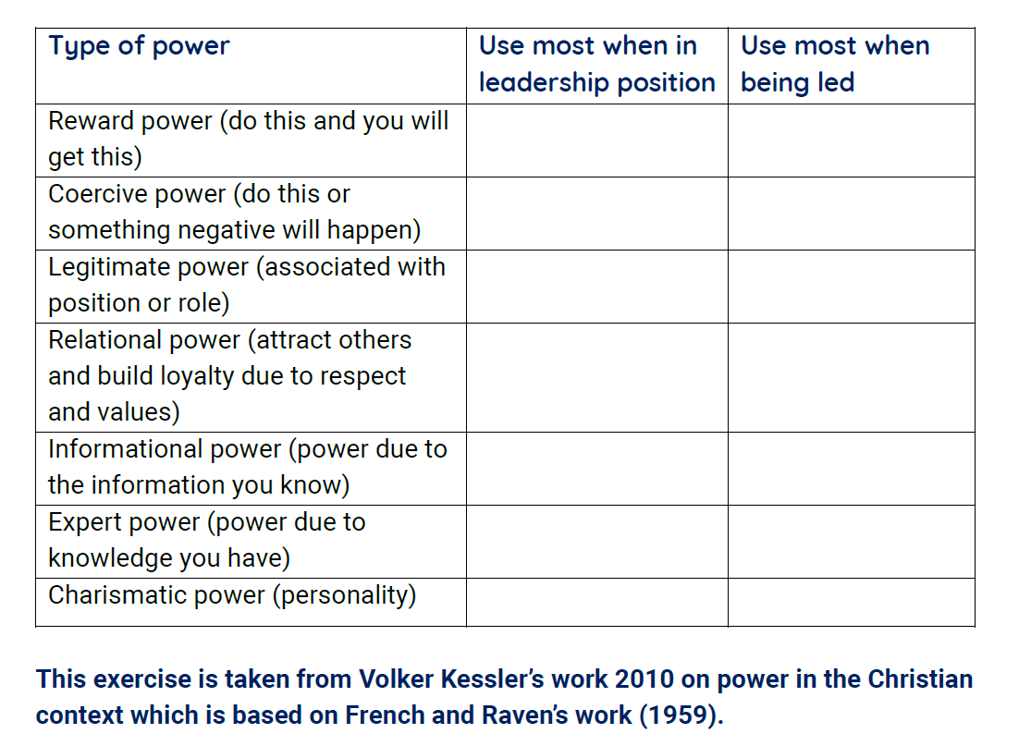
concerns should be heard
people should always agree
leaders should listen well
leaders should be held accountable
safe behaviours should be modelled

leaders should take responsibility
everyone should fit in
teaching should be rooted in scripture

those in roles should be safely recruited

